1.Write a program to reverse the String (use char[] or String built in method)

*LIJIN JOY - 211441*

**public** **class** Question1 {

**public** **static** **void** main(String[] args) {

String str="It was a beautiful day";

**char**[]ch=str.toCharArray();

**for**(**int** i=ch.length-1;i>=0;i--)

{

System.***out***.println(ch[i]);

}

}

}

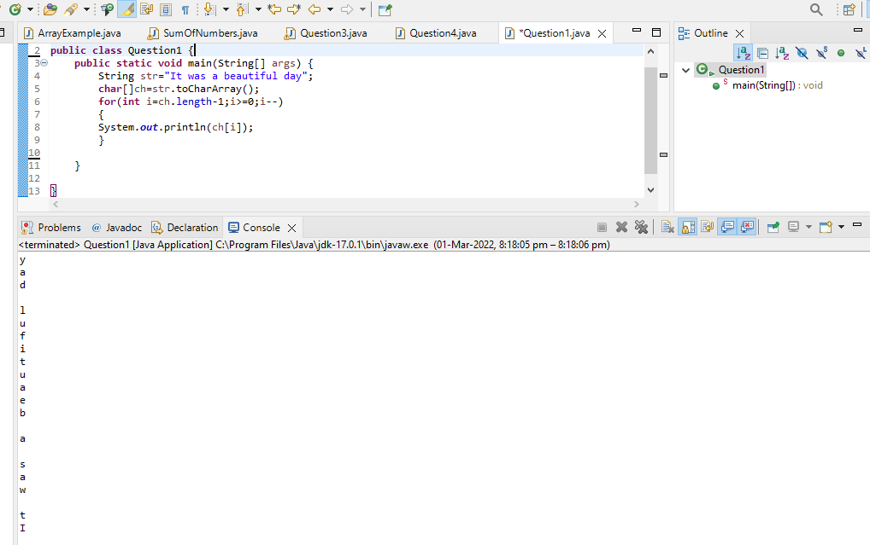

2.Write programs to depict the usage of contains(), length(), replace(), concat(), equals()

public class Question2 {

public static void main(String[] args) {

String str= "New york";

System.out.println("The length of this string is " +str.length());

System.out.println("Concat: " +str.concat("City"));

System.out.println("Replacing: " +str.replace("New york", "America"));

System.out.println("Contains: " +str.contains("City"));

System.out.println("Equality: " +str.equals("New york"));

System.out.println("Checking for Equality by ignoring the case :" +str.equalsIgnoreCase("New york"));

}

}

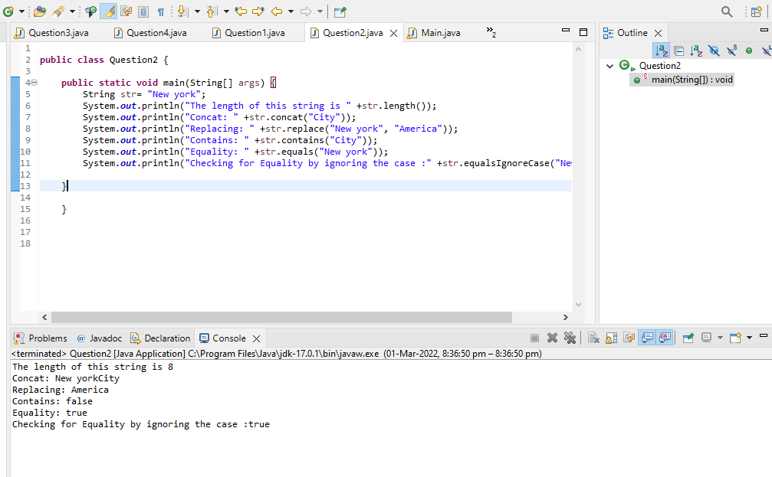

3.Write a customized Exception class for a Banking project.

**class** MinBalanceException **extends** Exception

{

**public** MinBalanceException ()

{

System.***out***.println ("Balance is low");

}

}

**public** **class** Main

{

**public** **static** **void** main (String[]args)

{

**try**

{

**int** acc[] = { 100, 101, 102, 103, 104, 105 }; // input can be got from runtime too

**double** balance[] = { 900, 2000, 1500, 1560, 1765.50 };

System.***out***.println ("Account No\t" + "Balance\t");

**for** (**int** i = 0; i < 5; i++)

{

System.***out***.println (acc[i] + "\t\t" + balance[i] + "\t");

**if** (balance[i] < 1000)

{

**throw** **new** MinBalanceException (); //throwing user defined exception

}

}

}

**catch** (MinBalanceException e)

{

System.***out***.println ("Exception caught");

}

}

}

